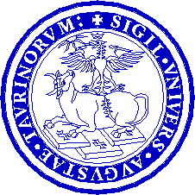  UNIVERSITÀ DI TORINO  Law School |  | 

ANNUAL CONFERENCE
of the Master of Laws (LL.M.) in Intellectual Property
International Seminar on
"3-Dimentional Printing and IP"
jointly organized by the World Intellectual Property Organization,
ITCILO and the University of Turin
Venue: ITC ILO, Viale Maestri del lavoro 10 – Turin
Europa New Building – Conference Halls 71-72
Monday, 24 October 2016

09:30– 10:15 | Welcome remarks by:  Mr. Giuseppe Casale, Director of the Turin School of Development, Turin  Ms. Martha Chikowore, Training Officer, WIPO Academy, Geneva  Professor Alessandro Cogo, University of Turin, Department of Law, Turin
10:15- 10:45 | Moderator: Professor Alessandro Cogo, Turin
Theme 1 | 3D printing and the future of IP
 | Speaker: Mr. Thomas Margoni, University of Glasgow, Glasgow
10:45 – 11:00 | Questions and answers exchange with the audience

11:00 – 11:30 | Moderator: Professor Alessandro Cogo, University of Turin
Theme 2 | Copyright principles in the 3d printing world
11:30 – 11:45 | Speaker: Mr. Paolo Marzano, LUISS University, Rome
 | Questions and answers exchange with the audience
11:45- 12:15 | Moderator: Professor Marco Ricolfi, University of Turin, Turin
Theme 3 | Going for Gold: The IP Implications of 3D Scanning and 3D Printing of Ancient and Modern Jewellery - A Case Study
 | Speaker: Professor Dinusha Mendis, University of Bournemouth, Bournemouth
12:15 – 12:30 | Questions and answers exchange with the audience
12:30 – 13:00 | Moderator: Professor Marco Ricolfi, Turin  Roundtable

[End of Program]

