Preparation
Please use your own computer for this study, i.e. a machine connected to a local internet service provider and not a foreign server.
Please note down in advance the URLs of the two sites you will visit.

Step 1. Browser configuration
i. If you already have Mozilla Firefox installed, please proceed to step 2.

ii. If you do not already have the Mozilla Firefox browser, please install it at https://www.mozilla.org/

iii. Skip the email registration step. Say “No” to the default browser option, if prompted. In the ‘settings’ menu (three straight lines in the upper right hand corner of the browser) click ‘options’, ‘privacy and security’, custom’, and set tracking and cookie protection to ‘off’.

Step 2: Install the Lightbeam add-on
iv. If you have the Firefox Lightbeam add-on already installed, please disable any add-ons (via ‘add-ons’ in the settings menu) and proceed to step 3.

v. If you do not already have the Firefox Lightbeam add-on, please install it by copying the following link into the address bar of your Mozilla Firefox browser: https://addons.mozilla.org/en-US/firefox/addon/lightbeam/ and adding it to the browser by clicking the button “Add to Firefox”.

vi. When prompted with the following notice, click “Add”.
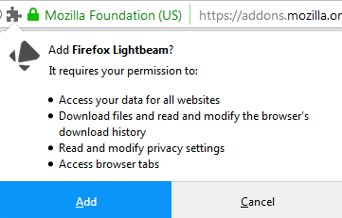

For your reference, Lightbeam's privacy policy can be found here: https://addons.mozilla.org/en-US/firefox/addon/lightbeam/privacy/. Once Lightbeam has been added, click “OK”. You can now close Firefox.

Step 3: Visit the news website
vii. Choose one mainstream domestic news provider in your country. For example, if a major national event occurred in your country, which news website would you visit first for information (excluding Facebook, Twitter, and other social media)? The website you plan to visit should be local/national to your country, rather than an international news website, and used by a significant proportion of population in your country; would cover a wide variety of news topics; is not politically extreme; and should not be something that makes you uncomfortable visiting for whatever reason.

viii. Please open the Mozilla Firefox browser and, if you have newly installed it, if prompted, select whether you wish to choose it for your default browser or not, depending on your personal preference.

ix. If you have Lightbeam already installed from before this experiment, please open it first and make sure you clear the data by clicking “Reset data”, marked with a red circle in the screenshot below, and then “OK”, when prompted. Set ‘tracking protection’ within the lightbeam window (in the top right hand corner) to ‘off’.
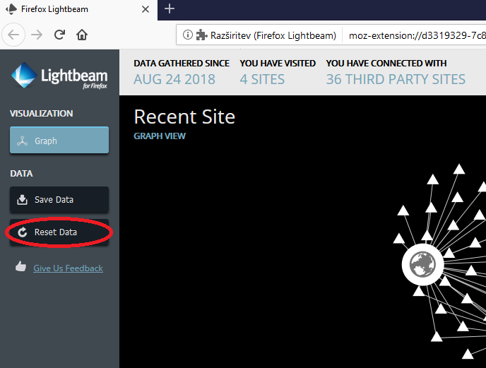

x. Enter into the browser’s address bar the link to the news website of your choice, based on the criteria outlined in paragraph 7. Please make sure you enter the direct link/full URL (in the format of, for example, www.localnewssite.com) into the address bar, rather than via using a search tool and then visiting the website. If necessary, you can use another web browser to copy/paste the link for accuracy.

xi. If the website asks you to accept cookies, please click “Accept”. Otherwise, do not click on any links on the website.

xii. Allow the website to fully load. Scroll down to the bottom of the page, but do not click on any links. In order to ensure unbiased data, do not load any other websites in Mozilla Firefox during this process

Step 4: Data collection/export (news)
xiii. Open the Lightbeam add-on by clicking on the Lightbeam icon on the right side of the browser, marked with a red circle in the screenshot below. Please wait for around 60 seconds to allow all the trackers to load.
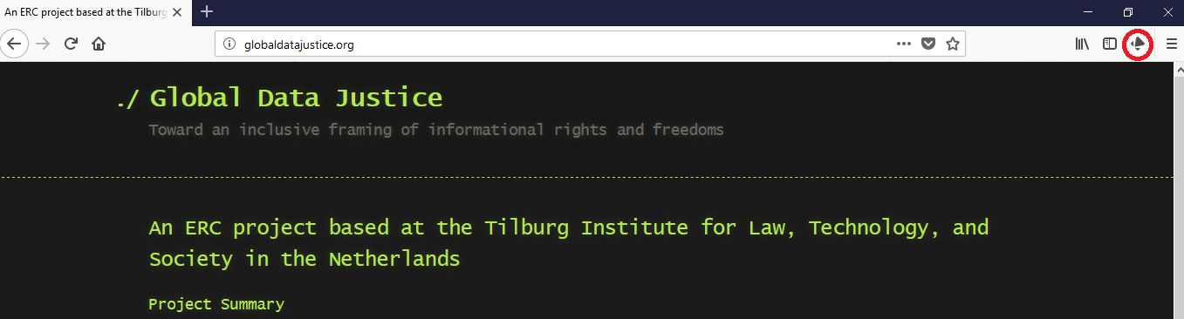

xiv. Then, while still in Lightbeam, click “Save Data”, marked with a red circle in the screenshot below, once.
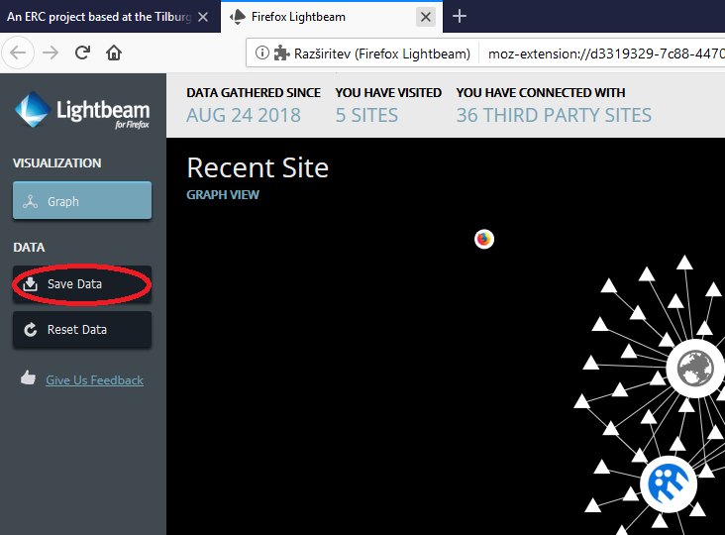

xv. The file will be saved as a .json file in your Downloads folder, which you will need to open to retrieve the file. Please click the arrow symbol in the top right corner of the browser, marked with a red circle in the screenshot below, and open the file.
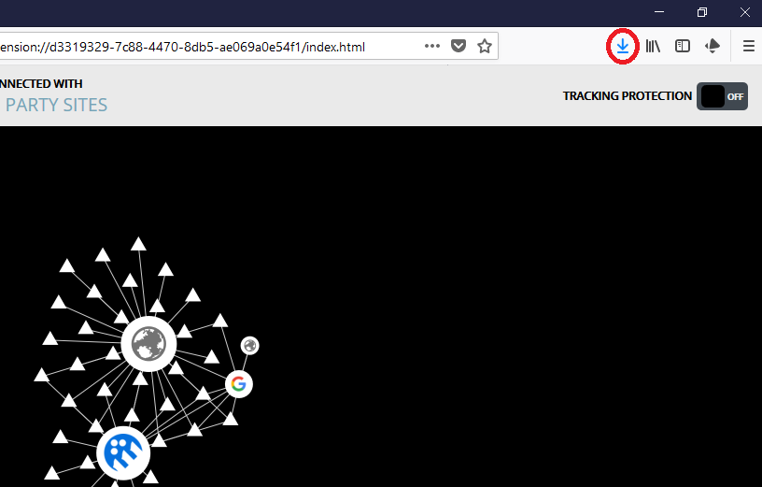

xvi. Once the .json file is opened, please go to “File” and choose “Save as”. Save file as in the example format: Your country’s name-news-date of data collection.json (for example, Netherlands-news-15-6-2018.json).

Step 5: Visit the mobile operator website
xvii. Close Firefox, open it again, open Lightbeam, click "Reset Data", and press OK when prompted.

xviii. As before, choose one major mobile network operator’s website within your country. (These companies may also be referred to as cellular service providers or GSM providers.) Enter into the browser’s address bar the link to the mobile network operator of your choice. Please make sure you enter the direct link/full URL (in the format of, for example, www.localmobilenetworkoperator.com) into the address bar, rather than via using a search tool and then visiting the website. If necessary, you can use another web browser to copy/paste the link for accuracy.

xix. As before, if the website asks you to accept cookies, please click “Accept”. Otherwise, do not click on any links on the website.

xx. As before, allow the website to fully load. In order to ensure unbiased data, do not load any other websites in Mozilla Firefox during this process

Step 6: Data collection/export (mobile network operator)
xxi. As before, open the Lightbeam add-on by clicking on the Lightbeam icon on the right side of the browser. Please wait for around 60 seconds to allow all the trackers to load.

xxii. As before, while still in Lightbeam, click “Save Data” once.

xxiii. As before, the file will be saved as a .json file in your Downloads folder, which you will need to open to retrieve the file. Please click the arrow symbol in the top right corner of the browser and open the file.

xxiv. As before, once the .json file is opened, please go to “File” and choose “Save as”. Save file as in the example format: Your country’s name-mobile-date of data collection.json (for example, Netherlands-mobile-15-6-2018.json).

Step 7: Reporting
xxv. Please email the two .json files (news and mobile network operators) and the signed consent form to the Global Data Justice research team at: info@globaldatajustice.org. Please also include in your mail any details you think we should know about your system (e.g. operating system, any add-ons installed in Firefox)

xxvi. You can now uninstall the Lightbeam add-on if you wish by going into the Mozilla Firefox menu in the top right corner, then clicking “Add ons”, and selecting “Remove” for Firefox Lightbeam.
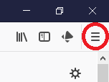

xxvii. If you wish to uninstall the Mozilla Firefox browser from your computer, please follow the instructions provided on this link: https://support.mozilla.org/en-US/kb/uninstall-firefox-from-your-computer.

Troubleshooting
xxviii. If you encounter any problems during this process, please contact us at info@globaldatajustice.org

